1. Install Power BI Desktop and share the final screenshot of the report view page which appears when power desktop starts.

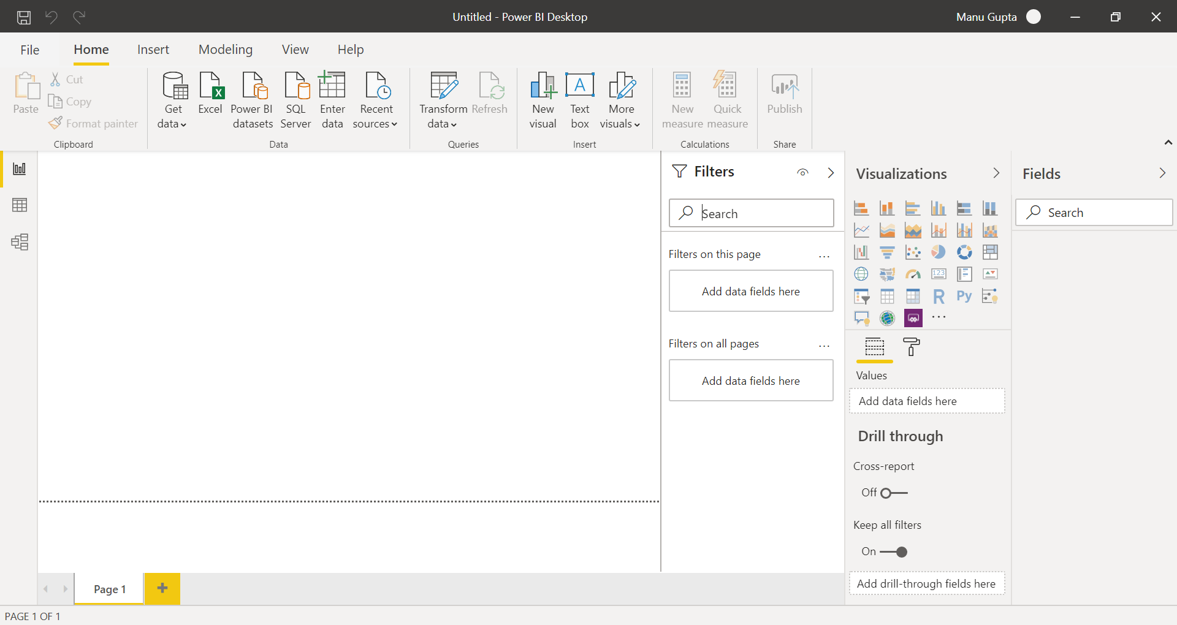

1. Prepare a document with the following screenshot

* *Report View*



* *Data View*

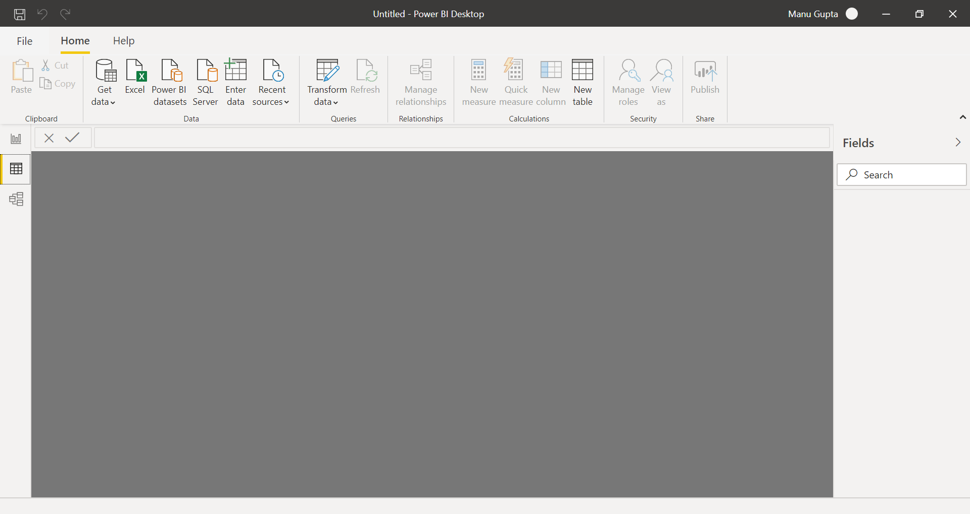

* *Model View*

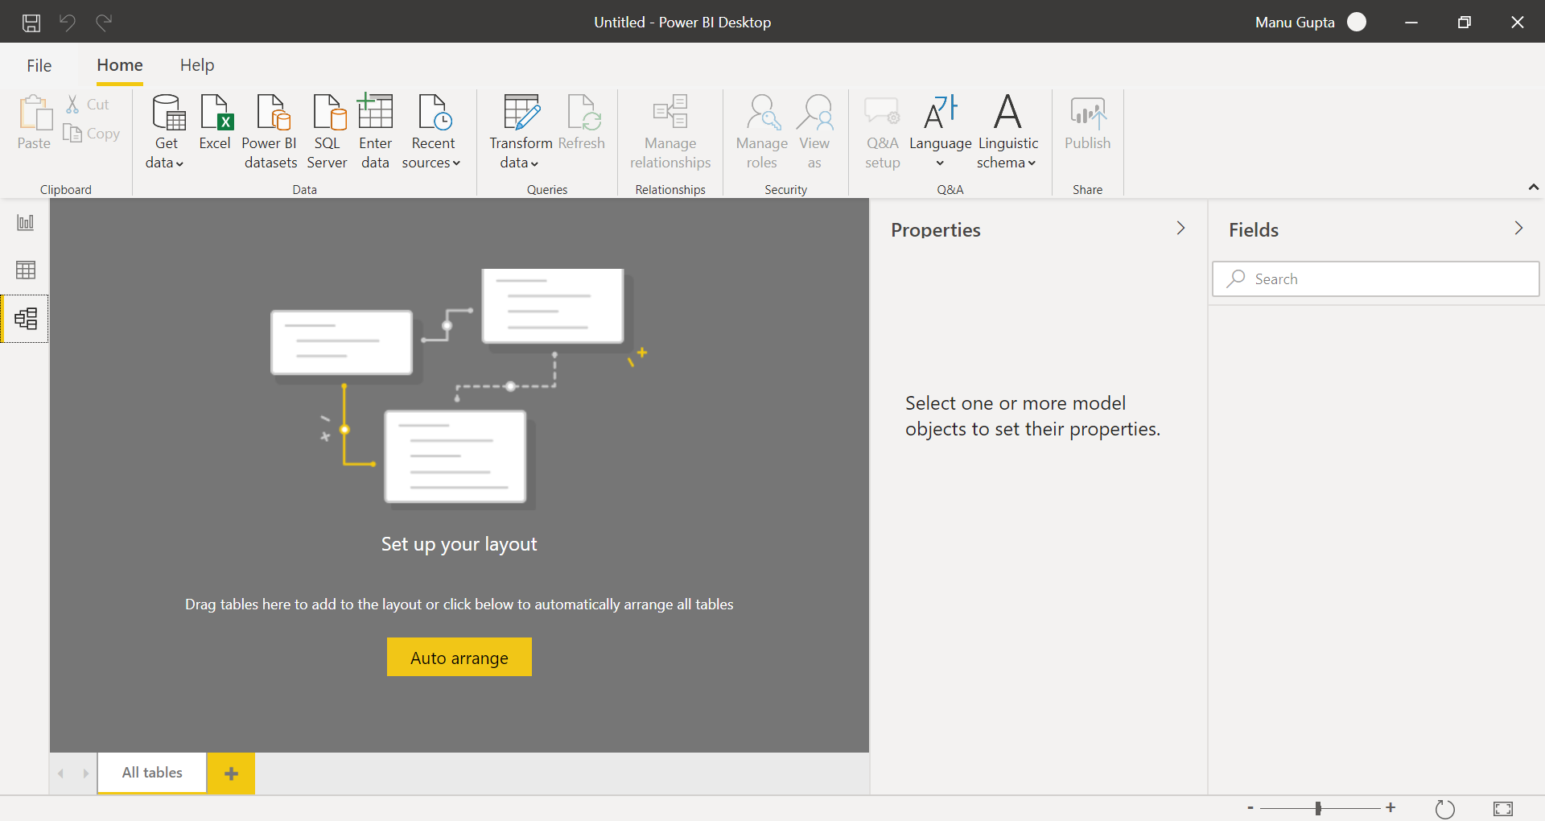

* *Power Query Editor*

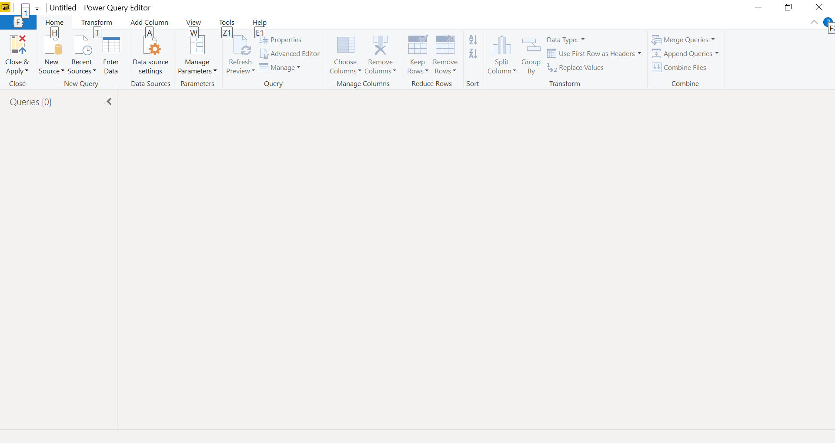

* *Advance Editor*

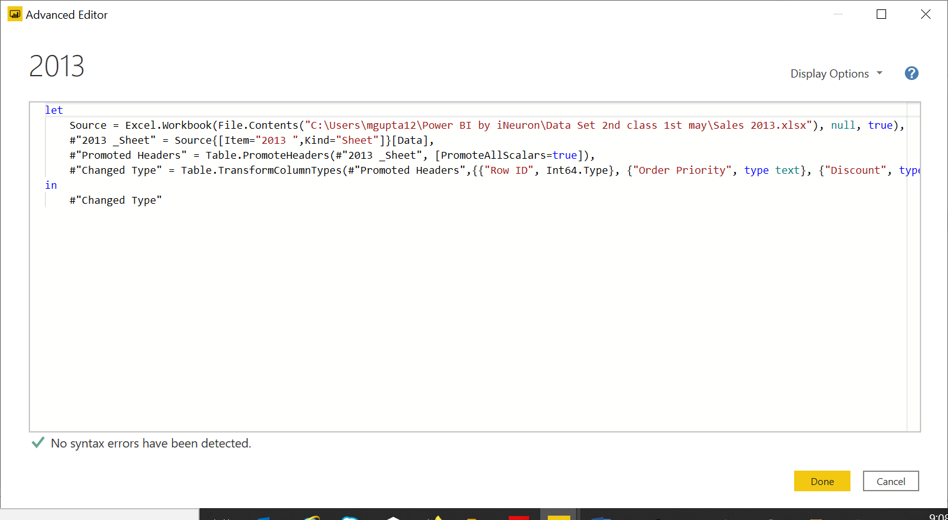

1. Prepare a document with details of the following along with their price

* *Power BI Desktop*

Microsoft Power BI Desktop is built for the analyst. It combines state-of-the-art interactive visualizations, with industry-leading data query and modeling built-in. After you connect to a data source, you can shape the data to match your analysis and reporting needs.

**Pricing**: It is free for individual users.

* *Power BI Pro*

Power BI Pro is an individual user license that lets users read and interact with reports and dashboards that others have published to the Power BI service. Users with this license type can share content and collaborate with other Power BI Pro users.

**Pricing**: $9.99 per user per month

* *Power BI Premium*

Power BI Premium is a capacity-based offering that includes: Flexibility to publish reports broadly across an enterprise, without requiring recipients to be licensed individually per user. Greater scale and performance than shared capacity in the Power BI service.

**Pricing**: It starts at $4,995 a month per dedicated cloud compute and storage resource.